SCH4C November 2017
Review for Test #2: Quantities in Chemistry
Name:
In order to do well on the unit test, you need to be able to:
- Determine the number of significant digits in a measured number
- Apply the rules for adding and subtracting measured values (Rule #1) and for multiplying and dividing measured values (Rule #2)
- Understand what is meant by the term mole
- Understand what the measurements volume and mass represent
- Use the symbols and units appropriately for mass, molar mass, moles, volume, concentration
- Calculate the molar mass of elements and compounds
- Calculate mass of a substance using the formula m = n x mm
- Calculate the number of moles of a substance using the formula n = m/mm
- Understand what is meant by the terms concentration, solution, solute and solvent
- Convert mL to L
- Calculate the concentration of a solution using the formula: C = n/V
- Calculate moles using the formula n = C x V
- Calculate the mass needed to make a solution of a given volume and concentration
- Describe how to make a standard solution starting from a solid solute, identifying the glassware needed
- Know how to use the dilution formula C₁V₁ = C₂V₂
- Describe how to make a standard solution starting from a concentrated solution, identifying the glassware needed
- Calculate either the volume (V₁) or concentration (C₂) when diluting a solution
- Know how to determine the concentration of a solution using the three methods we used in class: by evaporating a sample, by colour comparison, and by using a spectrometer

The following sample questions will help you prepare for the test. The test will NOT be open book but you will be able to refer to this review assignment.
- In what ways are the terms dozen and moles similar?

- Determine the number of significant digits in the following.
- 2051 | - 0.236 | - 0.001

- How many decimal places should be recorded in the following calculations?
- 10.1 + 20.6 | - 2.15 + 1.001 | - 2.2 + 2

- How many significant digits should be recorded in the following calculations?
a) 15 x 25.0 | b) 150 /22.5 | c) 136/125.65
- Name the following pieces of equipment that we have used in this unit. What is it used for? How is it used?
Equipment | What is it used for? | How to use it/special instructions?
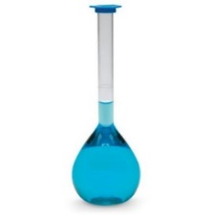
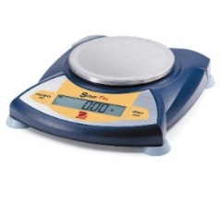
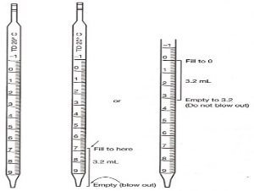
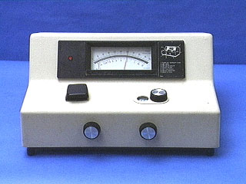
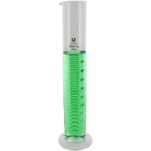

- Match the following units with the correct symbol.
Symbol | Units
m | mL or L
V | mol/L
mm | g
C | mol
n | g/mol

- Calculate the molar mass of the following.
- Br | - Cl₂ | - KBr
- Na₂O | - C₃H₅OH | - Pb(SO₄)₂

- Convert the following volumes to L
- 250 mL | - 15 mL | - 5 mL

- Determine the number of moles (___) for the following: [FORMULAS to USE: or ]
- 15.0 g of KBr | - 0.15 g of H₂O
- 25 mL of 0.10 mol/L NaCl | - 2.0 L of 0.50 mol/L KBr

- Calculate the mass (____) of the following substances: [FORMULA to USE: ]
- 1.5 mol KBr | - 0.222 mol of C₃H₅OH

- Calculate concentration (___) of the following solutions: [FORMULA to USE: ]
- 5.0 mol of KBr in 500 mL of solution | - 10.0 g of Na₂O dissolved in 2.0 L of solution

- Calculate concentration (___) of the following solutions: [FORMULA to USE: ]
- 10.0 mL of 0.50 mol/L solution of KBr is diluted to a volume of 100 mL | - 5.0 mL of 0.10 mol/L solution of KBr is added to a 250 mL volumetric flask and water is added to the fill line.

- Suppose that you are asked to make 500 mL of a 0.250 mol/L solution of NaCl. You will begin with solid NaCl.
- What two pieces of equipment will you need?

- What is the volume of the solution that you will be making?

- What must you do to the volume before you can begin to use it in a calculation?

- What is the first calculation that you must make?

- What is the second calculation that you must make?

- Go ahead and make these two calculations.
Calculation 1 | Calculation 2

- Describe how you would go about making this solution to a student who has never made a standard solution before. Include all amounts and equipment in your description.

- Suppose that you are asked to make a 250 mL solution of a 0.100 mol/L NaOH. You are given a 1.0 mol/L solution of NaOH.
- What two pieces of equipment will you need?

- What volume of the 1.0 mol/L solution will you need?

- Describe how you would go about making this solution to a student who has never made a standard solution before. Include all amounts and equipment in your description.

15. Lab-based question
A student is asked to determine the concentration of a solution of KBr. He does so by removing 10.0 mL of the solution of KBr from a container and evaporating away the water portion of the solution. He determines that 1.23 g of the solute, solid KBr, is left behind.
- What volume of solution, in L, was removed from the container?

- What mass of KBr was in the solution that was removed from the container?

- How many moles of KBr was in the solution that was removed from the container?

- What is the concentration of the solution of KBr?

